 Dovetail Landscape & Maintenance
◄ Mar 2026 | April 2026 |  |  |  |  | May 2026 ►
Sun | Mon | Tue | Wed | Thu | Fri | Sat
 |  |  | 1 Passover  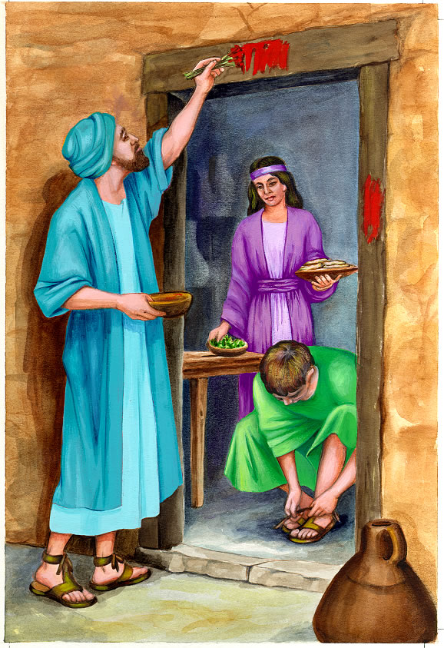 | 2 Holy Thursday  Woodlands 5 Turf Insect Spray | 3 Good Friday   | 4 School Librarian Day  
5 Easter  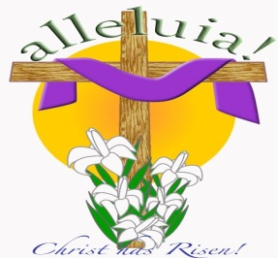 | 6 Dyngus Day   | 7 World Health Day  Woodlands 5  1st Turf Cut | 8 | 9 | 10 Appreciation Day Golf   | 11
12 Devine Mercy   | 13 | 14 National Dolphin Day   | 15 Tax Day (Taxes Due)   | 16 | 17 | 18 World Circus Day  
19 | 20  Woodlands 5  2nd Turf Cut  Flower Beds & Shrubs | 21 | 22 Administrative Professionals   | 23 Lover’s Day   | 24 Arbor Day | 25
26 | 27 | 28 Great Poetry Rading Day   | 29 | 30 National Honerst Day  

