 Dovetail Landscape & Maintenance

◄ Apr 2026 | May 2026 |  |  |  |  | Jun 2026 ►
Sun | Mon | Tue | Wed | Thu | Fri | Sat
 |  |  |  |  | 1 May Day   | 2  
3 | 4 Star Wars Day   | 5 Cinco De Mayo  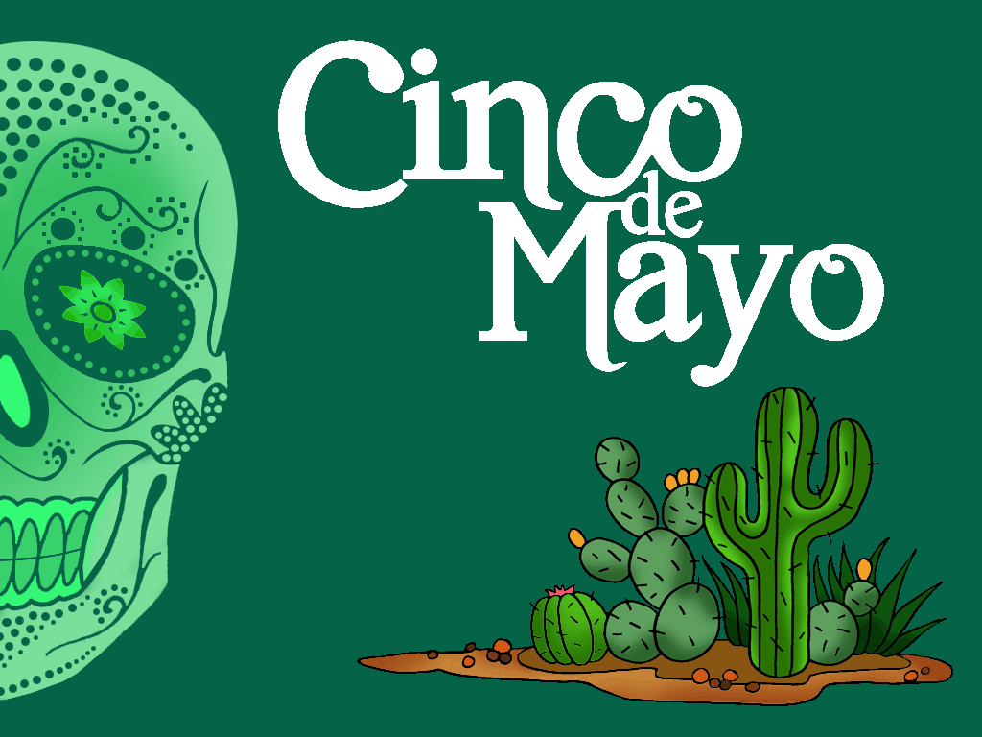 | 6 National Nurses Day  Woodlands 5  1st Turf Cut  Flower Beds & Hedges | 7 | 8 World Red Cross Day   | 9
10 Mother's Day   | 11 | 12 | 13 Leperchaun Day   | 14 | 15  Woodlands 5  2nd Turf Cut | 16 Armed Forces Day  
17 | 18 | 19 | 20 | 21 | 22 | 23 National Escargot Day  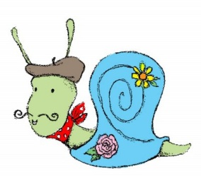
24 Water a Flower Day   | 25 Memorial Day   | 26 | 27  Woodlands 5  3rd Turf Cut | 28 | 29 | 30 World Jazz Day  
31

