 Dovetail Landscape & Maintenance
◄ May 2026 | June 2026 |  |  |  |  | Jul 2026 ►
Sun | Mon | Tue | Wed | Thu | Fri | Sat
 | 1 | 2  Woodlands 5 Turf Insect Spray  Granular Fertilization | 3 World Bicycle Day   | 4 | 5 World Environment Day  Woodlands 5 1st Cut  Flower Beds & Hedges | 6 D Day  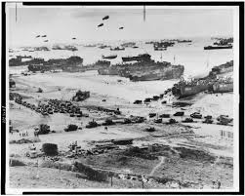
7 National Doughnut Day   | 8 Name Your Poison Day  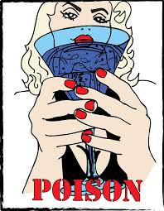 | 9 | 10 Iced Tea Day  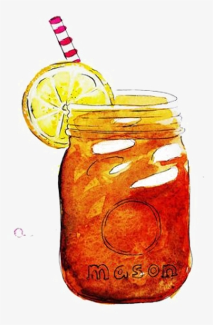 | 11 | 12 Red Rose Day   | 13
14 Flag Day   | 15 World Juggling Day   | 16  Woodlands 5 2nd Cut  Flower Beds & Hedges | 17 | 18 | 19 | 20 Summer Solstice  
21 Father's Day   | 22 Chocolate Éclair Day  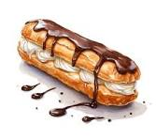 | 23 International Faery Day   | 24 | 25  Woodlands 5 3rd Cut  Flower Beds & Hedges | 26 Forgivness Day   | 27 Our Lady of Perpetual Help  
28 Log Cabin Day  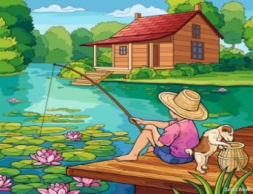 | 29 Meteor Day   | 30

