 Dovetail Landscape & Maintenance

◄ Aug 2026 | September 2026 |  |  |  |  | Oct 2026 ►
Sun | Mon | Tue | Wed | Thu | Fri | Sat
Suicide Prevention Month   |  | 1 International Bacon Day   | 2 | 3 | 4 Krishna Janmashtami  Woodlands 5 1st Turf Cut | 5 National Tailgating Day  
6 Intrnational Literacy Day   | 7 Labor Day  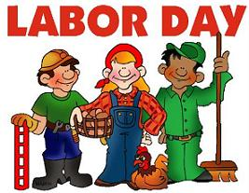 | 8 Star Trek Day   | 9 National Teddy Bear Day   | 10 World Suicide Prevention   | 11 Patriot Day   | 12 Holy Name of May  
13 Wife Appreciation Day   | 14 | 15 Our Lady of Sorrows   | 16 Mexico Independence Day  Woodlands 5 2nd Turf Cut  Flower Beds & Hedges | 17 Con stitution Day   | 18 | 19 Talk Like a Pirate Day arrgh  
20 Yom Kippur   | 21 International Peace Day   | 22 | 23 Autumnal Equinox | 24 | 25 Chinese Moon Festival Day  Woodlands 5 3rd Turf Cut  Flower Beds & Hedges | 26 Johnny Appleseed Day  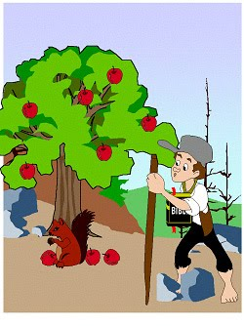
27 World Tourism Day   | 28 | 29 Feast of the Arch Angels   | 30

