 Dovetail Landscape & Maintenance
◄ Sep 2026 | October 2026 |  |  |  |  | Nov 2026 ►
Sun | Mon | Tue | Wed | Thu | Fri | Sat
Breast Cancer Awareness Month   |  |  |  | 1 International Coffee Day   | 2 | 3 National Golf Day  
4 Oktober Fest   | 5 | 6 Chinese Moon Festival  Woodlands 5 1st Turf Cut | 7 National Forgiveness Day   | 8 Take Your Teddy Bear to Work   | 9 Leif Errickson Day  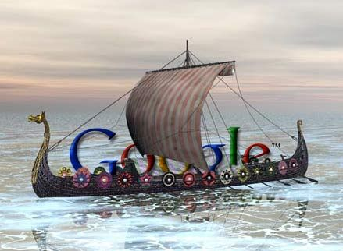 | 10 Moment of Frustration Day  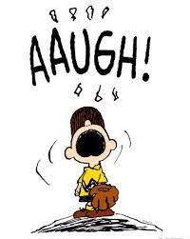
11 Motorcycle Ride Day  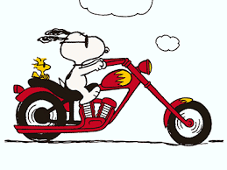 | 12 Columbus Day   | 13 | 14 | 15 White Cane Day  Woodlands 5 2nd Turf Cut  Flower Beds & Hedges | 16 National Boss’ Day   | 17
18 Mother in Law Day   | 19 Sweetest Day   | 20 | 21 | 22 Smart is Cool Day   | 23 | 24 United Nations Day  
25 Howl at the Moon  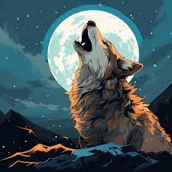 | 26 Frankenstein Day  Woodlands 5 3rd Turf Cut | 27 | 28 Black Cat Day  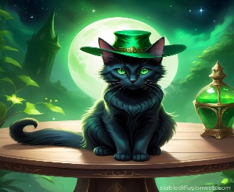 | 29 | 30 Mischief Night  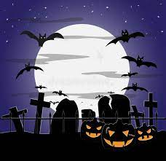 | 31 Halloween  

